Fruity- fruity
Eat fresh & delicious

Fruity- fruity offers a nice cold smoothie made out of delicious real fruit and you also get to make your own fruit cup.
Fruity- fruity will give your kids all the vitamins they need to be healthy

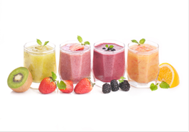

Lilia Gonzalez
87 Woodlawn park, SC
Liliagonzalez767@gamil.com
(864)3534102

